**Assignment 17 – Kubernetes Test Questions 7**

Date: 20 May 2024

Name: Mohamad Haffiz Bin Mohd Hissham

**Questions:**

1.

Create a **Persistent Volume (PV)** and a **corresponding Persistent Volume Claim (PVC)** and then use it in a Pod.

Create a Persistent Volume named **data-pv** with the following specifications:

Capacity: 2Gi

Access Modes: ReadWriteMany

HostPath: /mnt/storage

Storage Class: local-storage

Create a Persistent Volume Claim named **data-pvc** with the following specifications:

Requested Storage: 2Gi

Access Modes: ReadWriteMany

Storage Class: local-storage

Create a Pod named **app-pod** that **uses the PVC data-pvc** to **mount** the volume at **/data/app**.

**Verify** that the Pod is **running** and **using** the **Persistent Volume**.

**References:**

1. [Persistent Volumes | Kubernetes](https://kubernetes.io/docs/concepts/storage/persistent-volumes/%23reserving-a-persistentvolume)
   1. [Persistent Volumes | claims-as-volumes](https://kubernetes.io/docs/concepts/storage/persistent-volumes/#claims-as-volumes)
2. [Storage Classes | Kubernetes](https://kubernetes.io/docs/concepts/storage/storage-classes/)

**Steps:**

1. Volume can’t be created from command line, need to write a YAML script, **nano data-pv.yml**.
   1. Paste the code below and save the YAML file:

apiVersion: v1

kind: PersistentVolume

metadata:

  name: data-pv

spec:

  capacity:

    storage: 2Gi

  accessModes:

    - ReadWriteMany

  hostPath:

    path: /mnt/storage

  storageClassName: local-storage

1. Apply the YAML script to create the volume, **kubectl apply -f data-pv.yml**
2. Check persistent volume created, **kubectl get pv** .
   1. 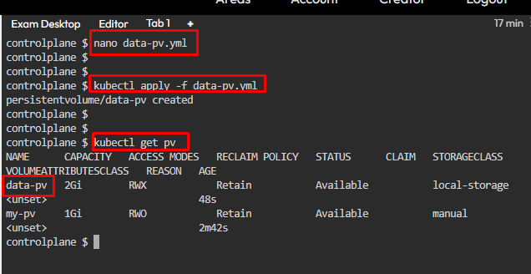
3. Create a **PVC** script, **nano data-pvc.yml**
   1. Paste the code below and save the YAML file:

apiVersion: v1

kind: PersistentVolumeClaim

metadata:

  name: data-pvc

spec:

  accessModes:

    - ReadWriteMany

  resources:

    requests:

      storage: 2Gi

  storageClassName: local-storage

1. Apply the YAML script to create the volume claim, **kubectl apply -f data-pvc.yml**
2. Check persistent volume claim created, **kubectl get pvc**
   1. A screenshot of a computer

      Description automatically generated
3. Create a YAML file to create/a pod with PVC volume attached, **nano app-pod.yml**
   1. Paste the code below and save the YAML file:

apiVersion: v1

kind: Pod

metadata:

  name: app-pod

spec:

  containers:

    - name: nginx-pod

      image: nginx

      volumeMounts:

      - mountPath: /data/app

        name: my-storage

  volumes:

    - name: my-storage

      persistentVolumeClaim:

        claimName: data-pvc

1. Apply the YAML script to create the pod, **kubectl apply -f app-pod.yml**
2. Verify the pod is running and using **Persistent Volume**, **kubectl describe pod app-pod**
   1. A screenshot of a computer program

      Description automatically generated